Sri Lanka Institute of Information

Technology



Lab Submission

Lab sheet No 09

**IT24103907**

**Pamindi M.M.**

**IT2120 - Probability and Statistics**

B.Sc. (Hons) in Information Technology

**Exercise**

1. Assume that the time taken to bake a batch of cookies is normally distributed with mean 45 minutes and standard deviation 2 minutes.

i. Generate a random sample of size 25 for the baking time.

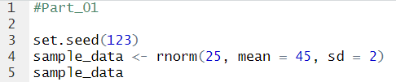

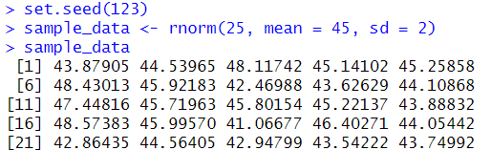

ii. Test whether the average baking time is less than 46 minutes at a 5% level of significance.

